Every Australian Counts Campaign –
Housing Stories

“A place I can proudly call home”?

A place I can proudly call home

Every Australian Counts is the community campaign which fought for the National Disability Insurance Scheme (NDIS).
Recently we asked our 160,000 supporters nationwide to share their personal housing stories in their own words.
To date, more than 650 individuals have submitted stories in which they describe the challenges they currently face. These stories shed light on the many people with disability who struggle to live well in the community. They also reveal the challenges experienced by their parents or carers to sustain their families in the face of housing problems.
But there are also stories of hope. We received countless submissions detailing the dreams, goals and aspirations of people with disability, as well as those of their loved ones, family members and carers.
From all the stories, what’s clear is that Australia faces a hidden crisis of unmet need for appropriate, accessible and affordable housing with support for people with disability. The challenges are also widespread – they are found in every jurisdiction in Australia and across all people with disability.
When we won the NDIS, parliamentarians across Australia were our champions. We now need disability ministers to once again lead the way on critical social reform.
We are writing to you to call on your governments to be disability
housing heroes. We have a once in a generation opportunity to tackle the disability housing crisis – but we must act now.
This report summarises the information drawn from more than 650 personal stories submitted to our website. Individual stories can be read here: everyaustraliancounts.com.au/housing-stories/
Each story is unique, but they all call out for positive change. Considered together they represent the voice of the disability community, and present a compelling case for urgent and nationwide action.
Kind Regards
John Della Bosca,
Every Australian Counts Campaign Director

The stats about disability housing

Right now there are:
- 6,381 young people in aged care facilities
- a growing number of ageing parents: 78,000 in 2012, who despair about what will happen to their children when they pass away or can no longer support their child
- massive waiting lists for accessible and affordable housing
By 2020, if no action is taken there will be up to 122,000 NDIS participants without appropriate disability housing.
We have an opportunity to address this growing crisis:
From 2018 the NDIS will have up to $700 million each year to invest in stimulating the construction of disability housing.

Quotes from the housing stories
I am still too young for a nursing home and I enjoy being around people especially those who like music.
Robert, Queensland
I want my 19 year old son who loves life and people to have access to an affordable, accessible home that he can share with mates and live a life that is typical of other young people: having friends over, chillin out at home, close to the ‘action’ so he can go to pubs and bars and visit friends at their homes as well as go to sports clubs etc. I know these are things he wants to do and it hurts him and his family that he doesn’t have the options that his siblings have because he cannot access stable, medium or longer term housing that meets his mobility and personal care needs.
Julie, Western Australia
We are now in our seventies and early eighties and very concerned, anxious and worried about the crisis in accommodation in Australia for intellectually disabled adults. We believe it is my son’s fundamental right to be safe, secure and cared for within the privileged society the rest of us enjoy.
Noela, Victoria

Who made a submission?

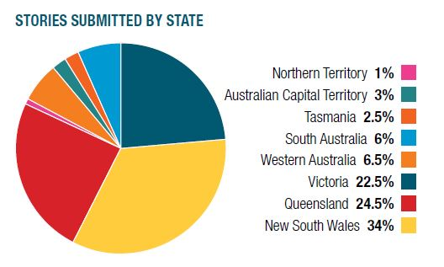
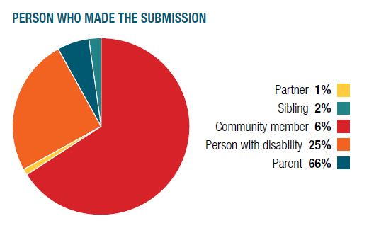
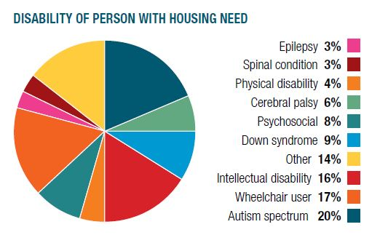

Current living arrangements

Individuals described their current housing circumstances in their own words. There is a mix of tenure, support location and service type described in the responses below.
Although all the stories are different, most describe situations where people with disability live in their own home, their ageing parents’ home or as under-eighteens in their younger parents’ homes, rather than in funded supported accommodation.
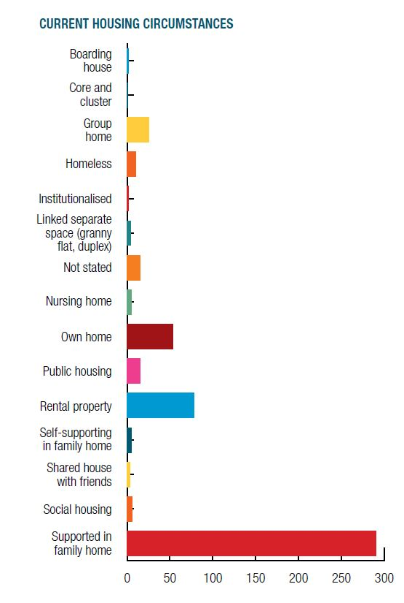

Quotes from the housing stories:

I think there should be further incentives for the acquisition and modification of public housing by tenants to meet the long term needs of people with disability and their families/carers – especially in cases where this can assist the individual to maintain independence, remain connected to/gain access to their community.
Melinda, ACT
We have been told the only way our son would receive a place in supported accommodation would be if he was homeless. I am consumed by stress wondering what will happen to my son if I get ill or pass away.
Noela, Victoria
I am 61 and my husband is 70. We have been caring for our disabled daughter for 38 years and are finding it very hard to continue. We would like her to move into suitable supported accommodation but are always told there is nothing available. How much longer do we have to wait? We would like just a few years to enjoy our retirement time, is that too much to ask?
Judy, Tasmania

Housing goals for the future

There is a large gap between what people with disability want for themselves or their family in the future and what they have now.
There is a clear message for policy makers – people with disability want to live in the community and in their own homes where they have autonomy.
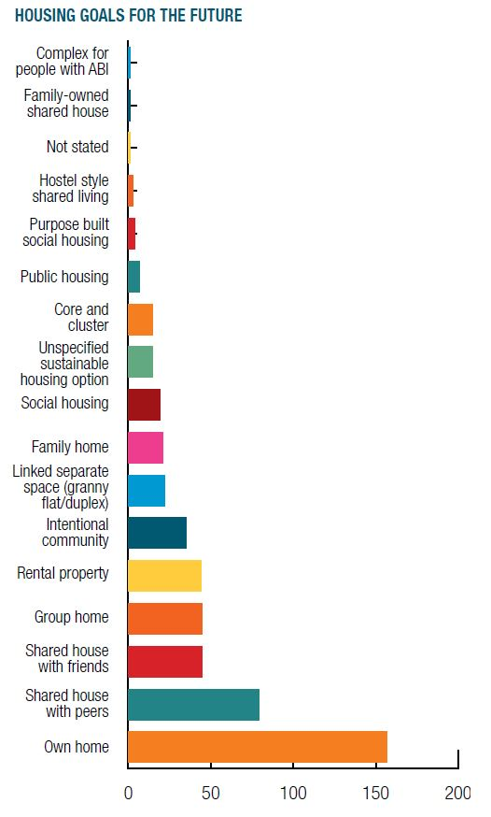
The big picture of the above graph suggests the following:
- About 53% of respondents express a desire to live in a home of their own (with or
without formal supports) that would not involve living with people other than their immediate family
- Almost 31% of respondents express a preference for forms of shared living that are comparatively new in the Australian disability context These are:
- Shared house – explicitly with no more than 2 or 3 peers
- Intentional community, which suggests living with other people with disability
- About 12% of respondents express a preference for supported accommodation models that are well-established in Australia. Examples include a condition-specific complex for people, core and cluster arrangements, group homes and hostel-style shared living
- Older parents are more likely to refer to traditional housing models such as group homes, while younger parents are more likely to talk about shared living in small units with 1 or 2 friends or peers
- No respondents expressed a wish to live in a large residential centre

Support arrangement preferences
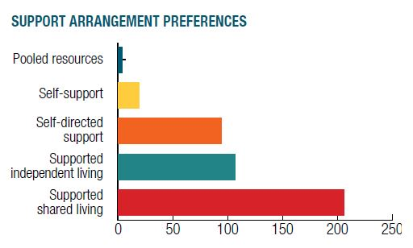

There is clear demand for independent, self-directed and supported shared living. This sends a message to policy makers that there is a need to trial new housing models such as shared housing and intentional communities.
We can also conclude that:
- Just over half (51%) of the respondents who expressed a clear preference told us they prefer to live in a home of their own that does not involve sharing with other people with disability.
- A further 10% told us they wished to live in a share house with one or two friends who may or may not be people with disability.
- Nearly 12% wrote that their preference was to live in either ‘core and cluster’ arrangements or ‘intentional communities’ in which each person has their own, private unit where they could be wholly self-sufficient (with support) if that was their choice. Such arrangements would have common facilities, areas and/or support arrangements that each individual could make use of.

Shared houses model

Shared houses have a maximum of three occupants. Individuals with disability live with friends who may or may not have a disability. In some circumstances people with similar interests, often in the same age group, or students in the sector, may live in the shared house to provide support to the person with disability in return for rent free accommodation.
Intentional communities model
Intentional communities take many forms. They include housing co-operatives, shared support, pooled resources and other projects in which people live together on the basis of explicit common values; not defined by disability type or the vacancy management priorities of housing providers.
Challenges ahead

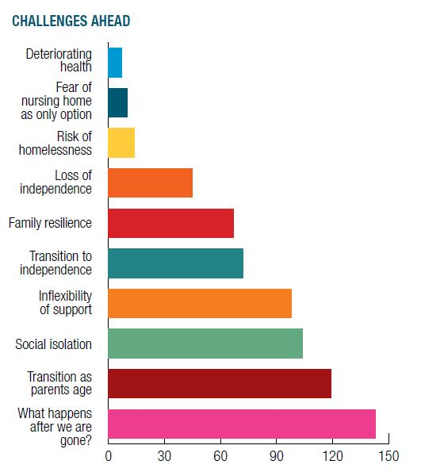
The key concerns raised in the contributions include:
- How to secure good housing futures as a result of parents being unable to continue to take on carers’ duties.
- Poor housing design, inaccessible features, universal design and home modifications which came largely from people with physical disability who use mobility devices but not exclusively so. Parents of young children with disability also speak of the costs of home modifications. People with sensory impairments and psychosocial disability as well as family members writing about a relative with an autism spectrum disorder are similarly concerned about the design and use of internal and external domestic space.

Quotes from the housing stories:

I am at the stage of my life where I’d like to finally move out of home … and put my degree into practice.
Stephanie, Queensland
If we die, where is she going to live? How can we make sure she is going to be cared for properly? The future is very frightening for us, and we are exhausted and don’t know how much longer we can take care of her.
Anonymous, New South Wales
The future is already uncertain because we have never had to consider this with our other children. What can we and our daughter expect will be available when the time comes for her to live her life independently just like her siblings?
Jenny, Queensland
It is very expensive for us to pay private rental and I always worry that the landlord will give us notice to leave.
Anne, Queensland

My housing goals
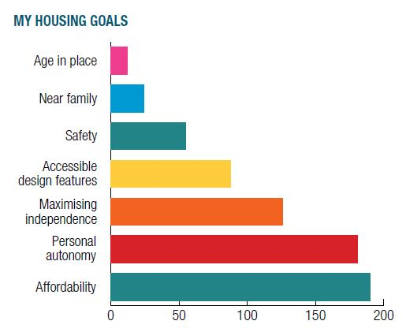
The drivers and challenges of future housing options unsurprisingly vary depending on who submitted the story, whether it’s a person with disability, family member or carer. But despite highlighting different perspectives, the stories also presented some recurring concerns, including:
- Affordability which is a very common, strong and recurring driver and concern.
- Safety – references came primarily from family members but not exclusively so. Safety is a concern expressed by people with disability too.
- Personal autonomy and maximising independence is the most common issue for people with disability, their families and carers. Across every form of housing type, tenure and model of support, people say they want to live in circumstances and with support models that maximise personal freedom. This includes helping people with disability achieve their full potential as fully realised individuals with rights, who are treated with respect and dignity, and become recognised and valued for who they are.

Quotes from the housing stories:

Unworkable is what my life is without being able to choose my life, living where I want.
Wesley, Queensland
Totally infuriating that we have to blow out our mortgage to look after or son’s access needs. No help whatsoever considering this is only happening because of
his disability.
Belinda, Victoria
My wife and I looked after our severely disabled daughter in our home for 25 years without complaint. But we can’t do it forever – we are in our late 60s. We also believe that people with a disability have a right to live independently. No-one should be forced to live with their parents solely because suitable accommodation is unavailable.
Adrian, New South Wales
When our sons leave home I will be able to go back to work after being a full time carer for 18 years which will take the strain off my husband as sole income earner for our family. We hope this future will be possible.
Jo, New South Wales

Conclusion

The crisis in disability housing has been building for the last decade, driven by the challenge created as the baby boomer generation ages and is no longer able to provide in-home support for their children with disability.
At the same time, the expectations and aspirations of people with disability and their families have expanded. In line with this, younger people with disability and their families have expressed a preference for living in shared housing with friends and peers, as part of the wider community. These preferences mirror the housing choices of many young Australians.
We believe that Australia is facing a crisis in the supply of appropriate accessible housing for people with disability. This crisis is clearly adding to the emotional strain of people with disability and their families who see few viable options. The longer governments take to develop a policy response, the greater the toll of inaction will be on the disability community.
We are not housing experts, all we have done is ask the disability community what they want. However, we see three potential policy responses that will tackle the accessible housing shortage: We ask governments who share responsibility for both social housing and the NDIS to make the commitment that:

- All new residential construction, at a minimum, is built according to the silver level Liveable Housing Australia accreditation standards. This would reduce the cost and increase the supply of accessible housing in Australia.
- The NDIA uses the NDIS trial sites to test and report on new models for creating accessible disability housing with a focus on stimulating private investment in new housing stock. This trial should inform the community and policy makers of the most efficient ways to increase housing options for people with disability.
- NDIS funding be allocated to delivering new housing for people with disability rather than maintaining existing housing stock. This will ensure a minimum of $700 million a year from 2019 will go towards increasing viable housing options for people with disability.
We recognise that people with disability and their families deserve answers from policy makers on how we will face this challenge as a nation. We fear that the high levels of uncertainty are causing great stress and concern for the disability community.
For this reason we are asking each State Minister to take immediate action to address these fears.
We invite each minister to:
- Meet a delegation of campaign supporters to hear firsthand about the housing challenges in their jurisdiction
- Make a video statement to Every Australian Counts campaign supporters outlining their government’s plan to tackle the disability housing crises.

